Online Student management system- web application
User login test cases

Module Name: Online Student management system-user login test cases(Web)
Test case ID: TC003
Platform: Web application(Responsive)
Login Method: username + password

Home page

Scenario ID: 1
Scenario: login with valid credentials
Test steps:
- Enter valid username :admin
- Enter valid password:Admin@456
- Click on login

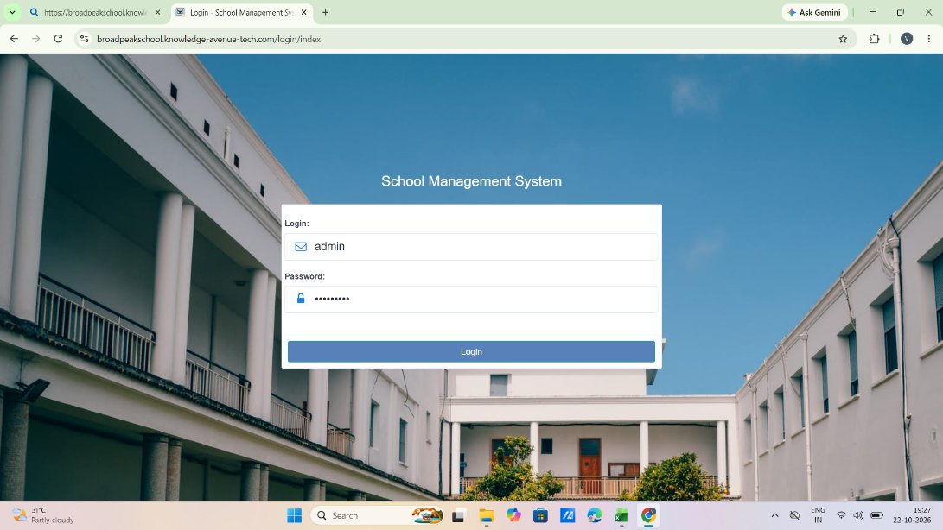

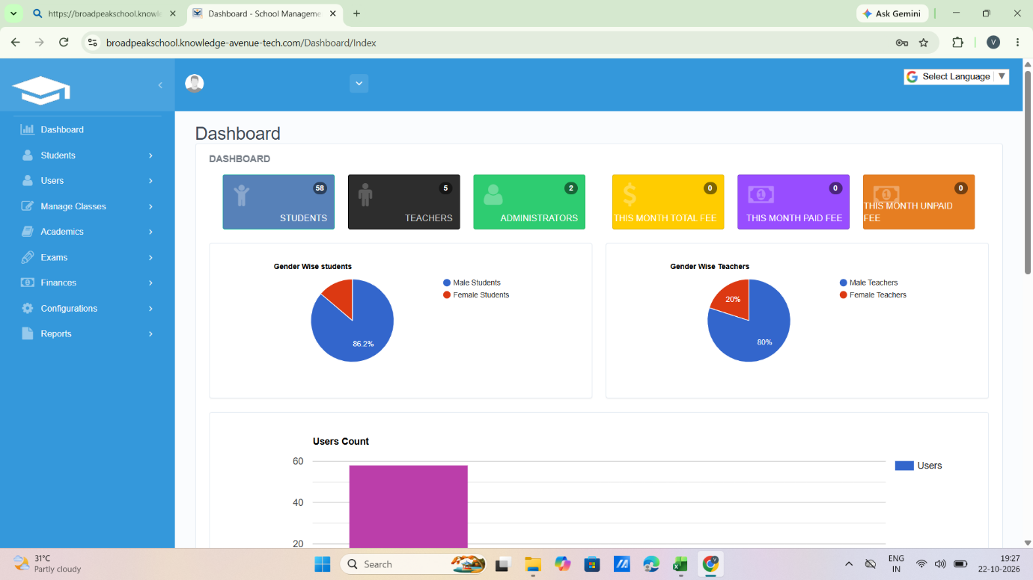
Scenario ID: 2
Scenario: login with valid username and invalid password
Test steps:
- Enter valid username :admin
- Enter valid password: wrongpass123
- Click on login

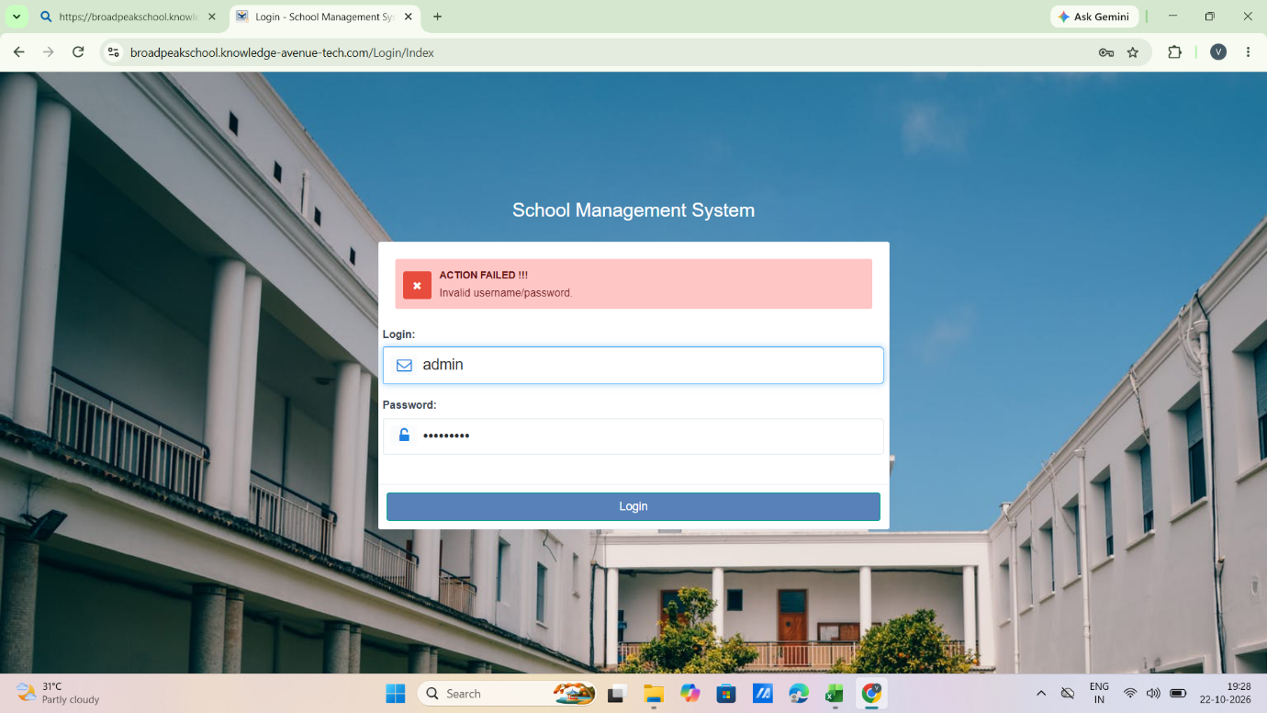

Scenario ID: 3
Scenario: login with invalid username and valid password
Test steps:
- Enter valid username :adminx
- Enter valid password:Admin@456
- Click on login

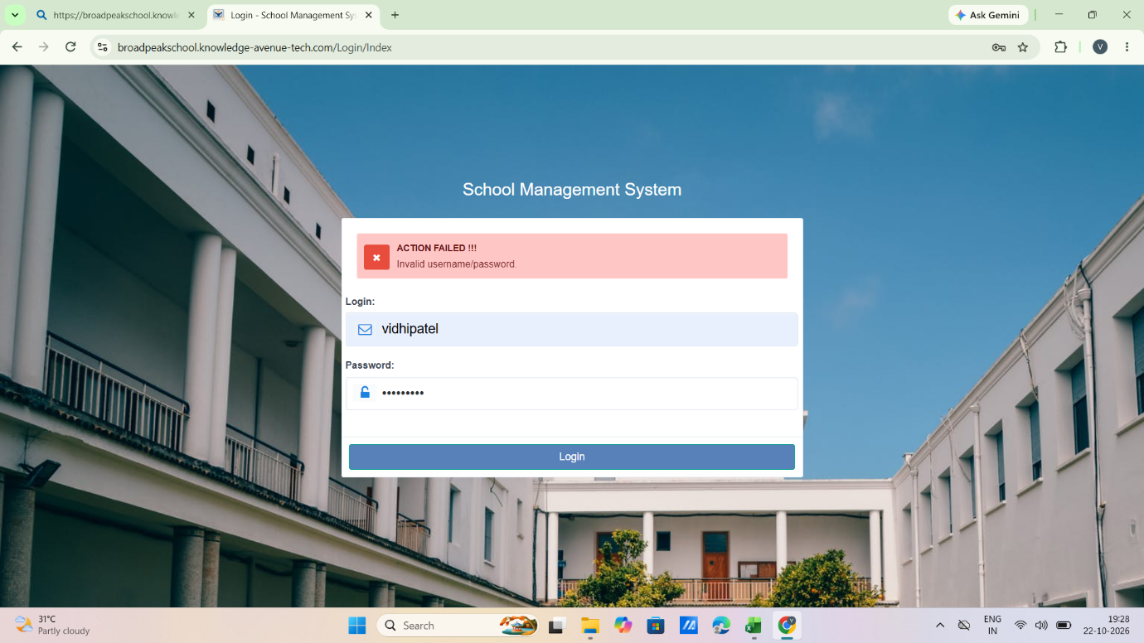

Scenario ID: 4
Scenario: login with both the fields blank
Test steps:
- Enter valid username :-
- Enter valid password: -
- Click on login

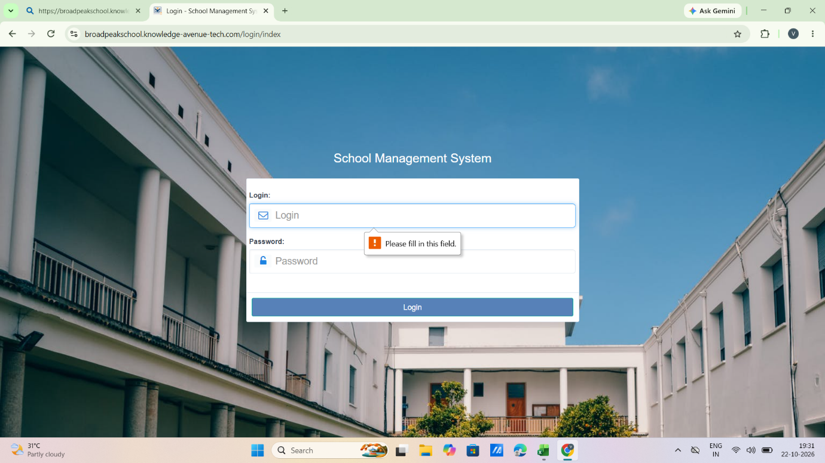
Scenario ID: 5
Scenario: login with valid username and leave the password field blank
Test steps:
- Enter valid username :admin
- Enter valid password:
- Click on login

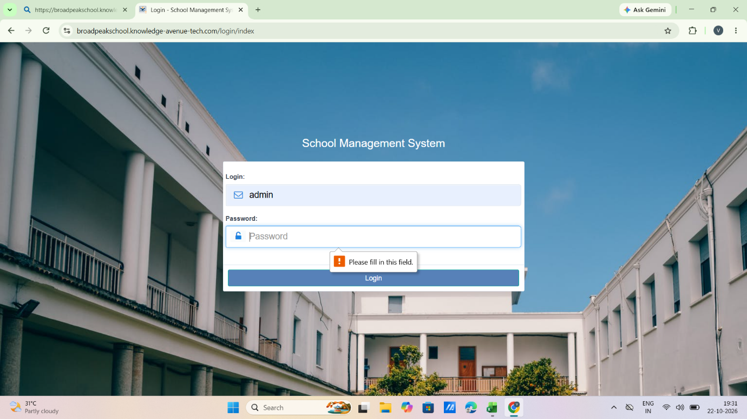

Scenario ID: 6
Scenario: login with valid password and leave the username field blank
Test steps:
- Enter valid username :-
- Enter valid password:Admin@456
- Click on login

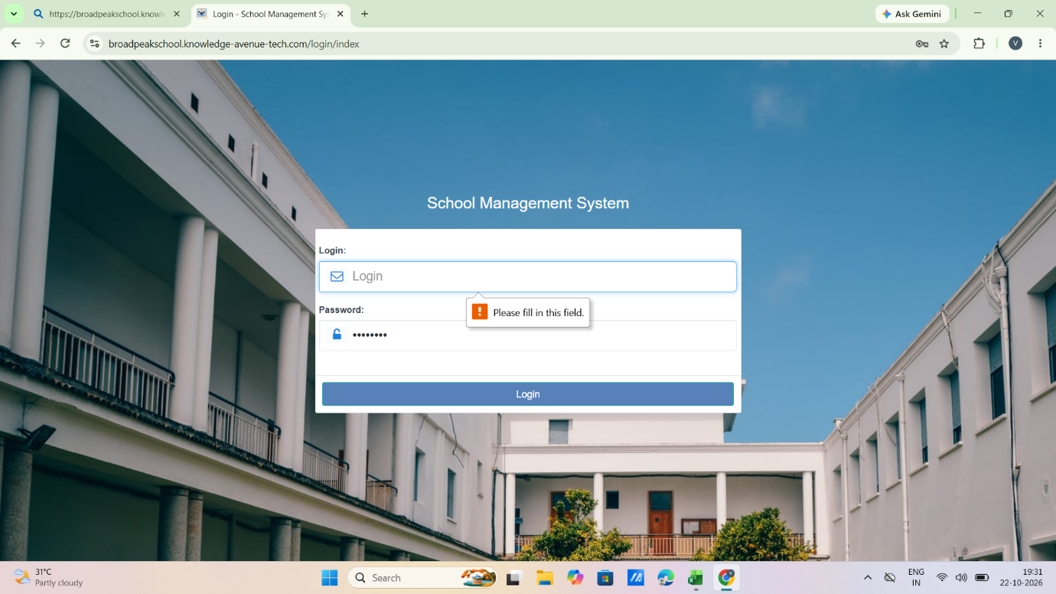

Scenario ID: 7
Scenario: password case sensitivity
Test steps:
- Enter valid username :admin
- Enter valid password:Admin@456_
- Click on login

Scenario ID: 8
Scenario: password field is masked
Test steps:
- Enter valid username :admin
- Enter valid password:Admin@4*56_
- Click on login

Scenario ID: 9
Scenario: Leading/trailing spaces in username
Test steps:
- Enter valid username : admin
- Enter valid password: Admin@456
- Click on login

Scenario ID: 10
Scenario: Submit login using Enter key
Test steps:
- Enter valid username : admin
- Enter valid password: Admin@456
- Press Enter

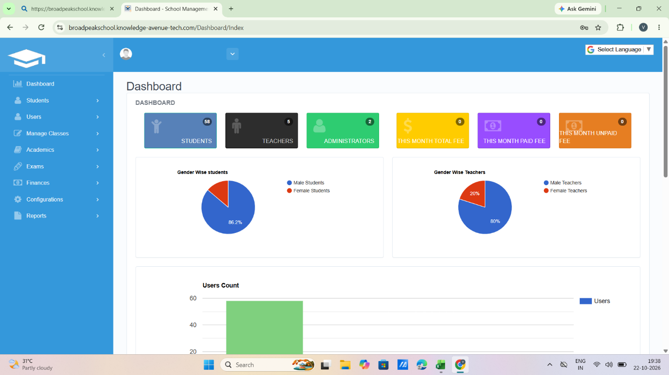
Scenario ID: 11
Scenario: Browser Back button after logout
Test steps:
- Enter valid username : admin
- Enter valid password: Admin@456
- Press Enter
